The Grid Problem - README

# Provided Observations/Assumptions

* Points form a grid in 2D space.
* Input points are in no particular order.
* The **grid is square** – there are the **same number of rows as columns**.
* The grid is fully populated – **there are no missing points**.
* The distance between two neighboring points in the same row or column is constant.
* Columns and Rows may or may not be aligned with the x and y axes.
* The number of columns and rows are arbitrary.

# Notes

* MVC architecture style loosely applied for separation of concern.
  + GridController
  + GridView
  + GridModel
  + DAL
  + Etc.
* Error/Exception Handling implemented to handle areas such as input file issues (existence, format/coordinate validity, etc.).
* Test files used (and included in project files) to examine conditions in the four quadrants of the 2D space with various grid sizes and degrees. See “Test Data” below for data file names and visualization of the plotted coordinates.
* The coordinate type is set as double, so the X/Y values are large:
  + **Min value:** -1.7976931348623157E+308
  + **Max value:** +1.7976931348623157E+308

# GitHub Project Location

https://github.com/revanko/TheGridProblem

# Test Data

grid_example.txt

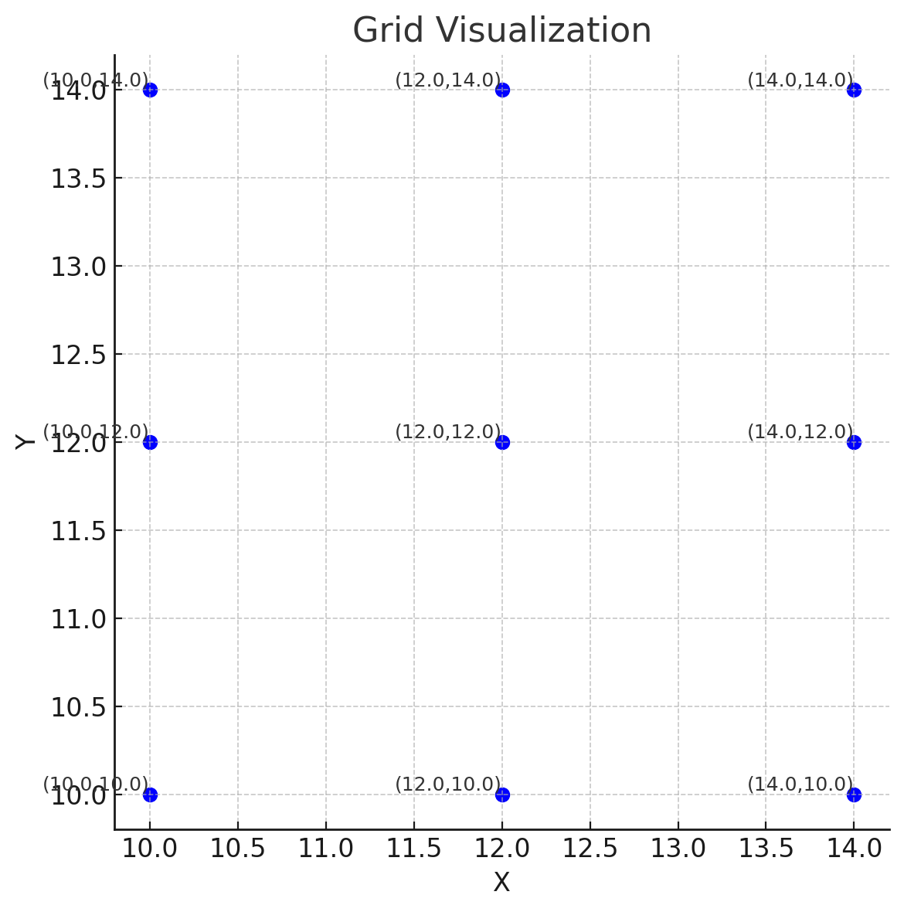

grid_input.txt

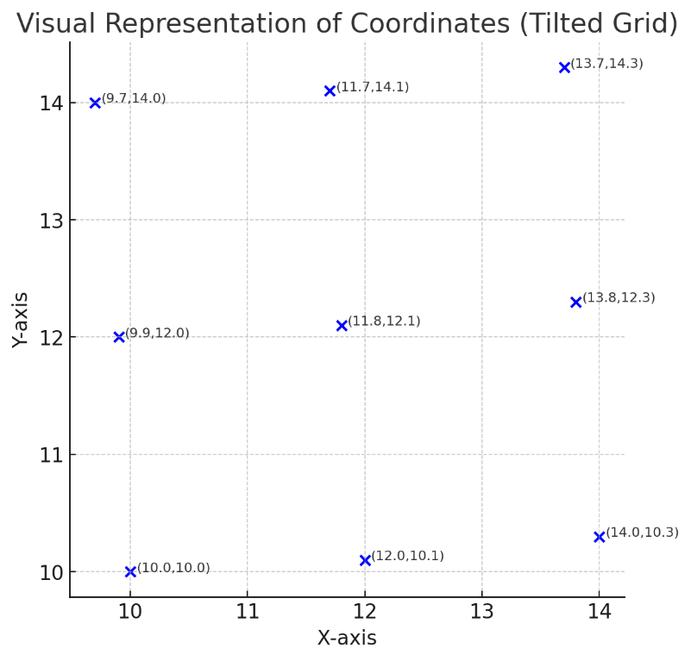

grid_5x5_25deg_quadrant_II.txt

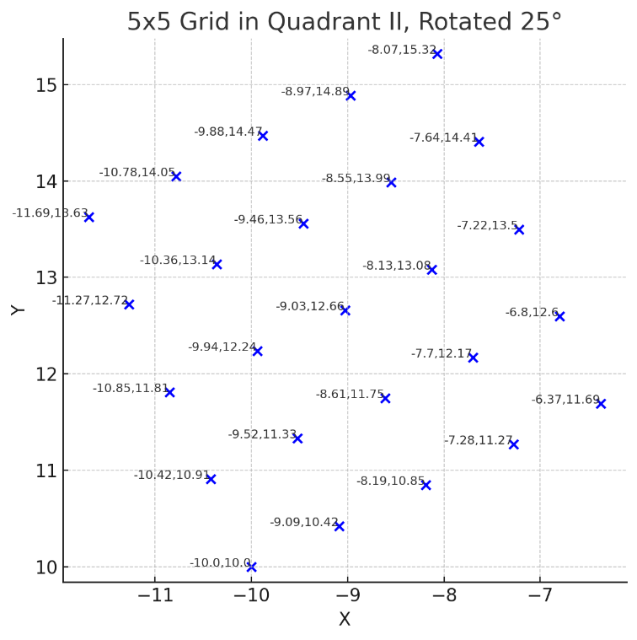

grid_5x5_neg25deg_quadrant_II

grid_4x4_35deg_quadrant_III

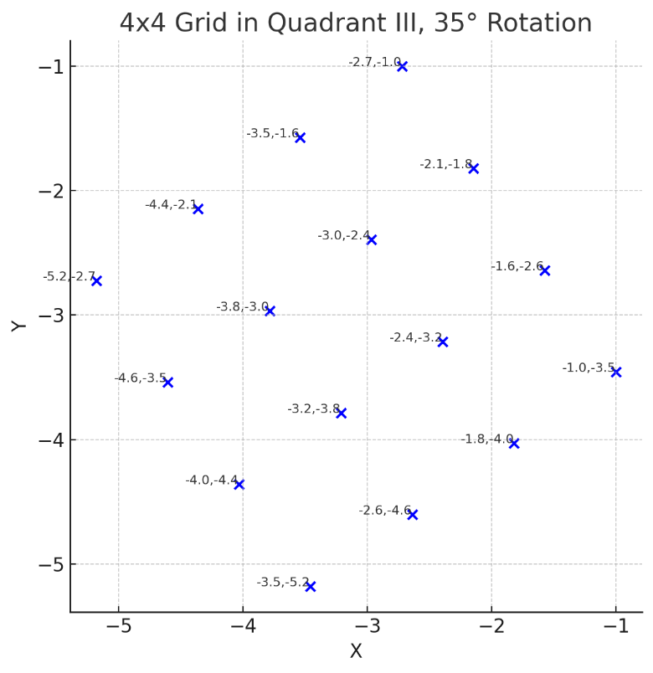

grid_4x4_quadrant_III

grid_6x6_neg10deg_quadrant_IV

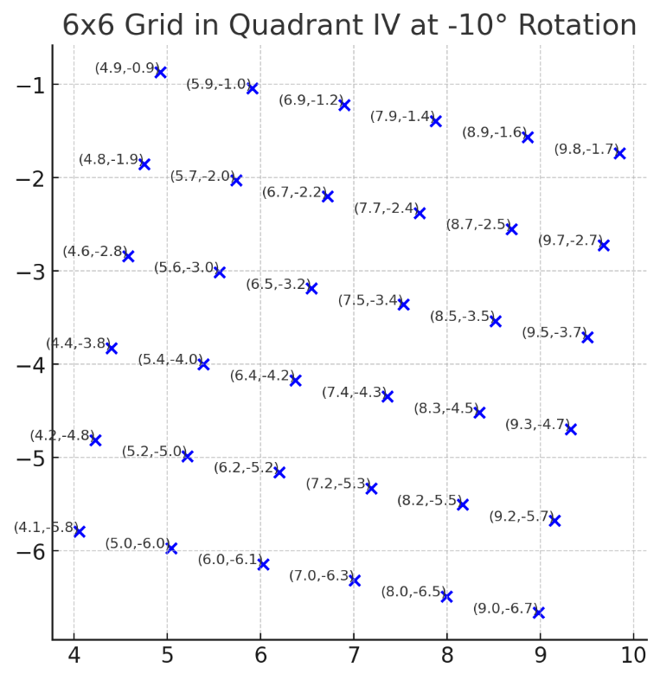

grid_6x6_10deg_quadrant_IV

